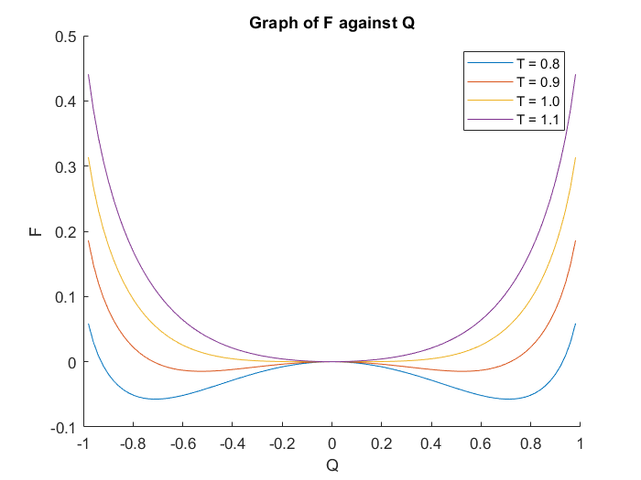

Figure 1: A graph of Free Energy (F) against Q. This graphs out the relationship predicted by the Bragg-Williams model – a dependence of the Free Energy (F) against the state of order defined by the order parameter Q. F generally increases for increasing values of T.

FF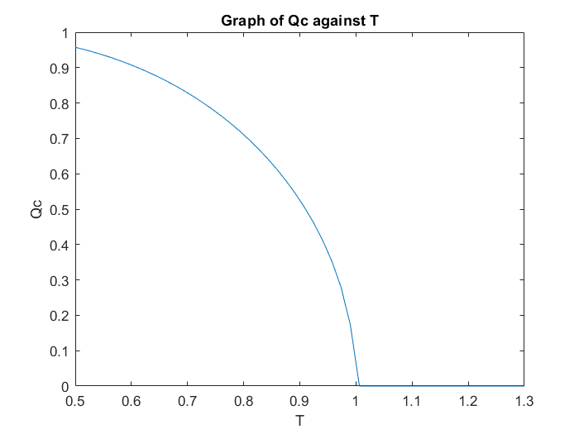

Figure 2: A graph of Qc, the value of Q that minimises the Free Energy (F), against T. Note that Tc = 1. As T increases, Qc decreases non-linearly, and reaches 0 when T = Tc = 1. As T increases past Tc, no amount of disorder can minimise the Free Energy, and only an entirely ordered system can minimise the Free Energy. For the region below Tc, only a more disordered system can minimise the Free Energy, probably reflecting the higher energy the system has due to the increase T.